Learning Focused Lesson Plan Lynn W. Evans

Each Learning activity Schedule Math 7 2 days Total of 9 days
Accelerated Math 1 day total of 5 days

Topic: Inequalities......This lesson will focus on inequalities, but will also give a review of solving equations.

Standard: 7.EE.4 Use variables to represent quantities in a real world or mathematical problem and construct simple equations and inequalities to solve problems by reasoning about the quantities.
A. Equations....Solve real world problems leading to equations of the form px + q = r and p(x+q) = r where p, q and r are specific rational numbers. Solve equations of these forms fluently. Compare an algebraic solution to an arithmetic solution, identifying the sequence of operations used in each approach.

B, Solve word problems leading to inequalities of the form px +q >r or px +q<r where p, q and r are specific rational numbers. Graph the solution set of the inequality and interpret it in the context of the problem.

Students will know:
To solve single step equations and inequalities using inverse operations.
How to assign a variable to a word problem.

Students will be able to:
Solve and evaluate multi step equations and inequalities.

Learning essential question: How can you use what you know about solving equations to solve two step inequalities and show the result in a graph?

Solving two step equations
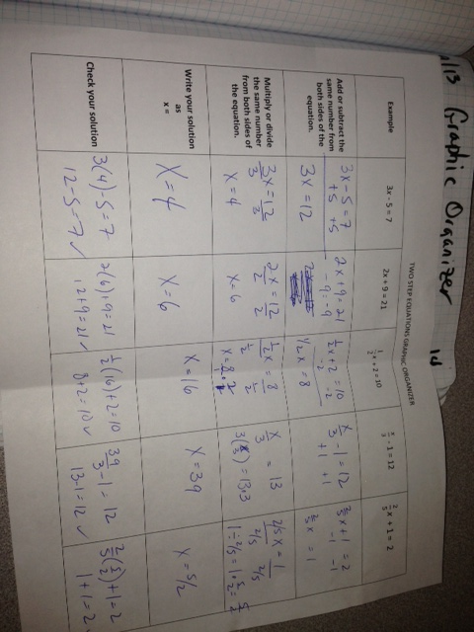

Activating strategy:
LA #1 Number line activity, Inequality symbols and Graphing workbook pages 67-69
LA #2 Solving and writing workbook pages 71-73
LA #3 Solving with tables showing the Mult/Div with a negative rule workbook pages 75-77
LA #4 activities involving areas, perimeters and volumes workbook pages 79-81

Key vocabulary to preview and vocabulary strategy:
Rational numbers, variable quantities, equations, inequalities....less than <, greater than >, less than or equal to < or =, greater than or equal to > or =, maximum, minimum

Lesson Instruction:
Learning activity #1: Writing and Graphing Inequalities

We need to remember the number line. A number to the left of number is less than. A number to the right is greater than.
-3 -2 -1 0 1 2 3
-3 is less than -1
1 is greater than 0
Use of key terms.....at least, less than, more than, no more than.......show chart on the top of page 126 in text.

A solution of an inequality is a value that makes the inequality true. The set of all solutions of an inequality is the solution set.
value of x x+2 < or = -1 is the inequality true?
-2 -2 + 2< or = -1
0 < or = -1 no........-2 is not a solution of the inequality
-4 -4 +2 < or = -1
-2< or = -1 yes, -4 is a solution and is in the solution set

Graph of an Inequality
y > -8 Show a number line at -8. Draw an arrow to the right with a hollow circle.
Hollow circle not include < or >
solid circle include <= or >=

Finish inequalities with the variable on the left. Then graph, may need to flip the inequality.
8 > y
y < 8 then graph arrow pointing to the left from 8 with an open circle.

Go over error analysis problem #10 page 128 in text
Twice a number x is at most -24
2x >= -24 ( should be 2x <= -24)

http://www.showme.com/sh/?h=O4NYL3I

Assessment prompt for LA #1

Use odd problems in the text on page 128.

Write word sentence for:
a number y is no more than -8
a number w added to 2.3 is more than 18

Tell whether the given value is a solution of the inequality
n+8 <=13 : try n = 4
p + 1.4<=0.5 : try p = 0.1

Graph the inequality
r <=9
g>2.75
x>=-3.5

Learning activity #2 Solving inequalities using Addition and Subtraction

We use inverse operations just like we did when we solved equations.

Addition property of Inequality
If a<b then a + c < b + c
If a >b then a + c > b + c

Subtraction property of Inequality
If a < b then a - c < b - c
If a > b then a - c > b - c

Example in text page 132

x - 5 < -3 to solve we add the inverse to both sides of the inequality. We add 5 to both sides.

+5 +5

x < 2 to graph we show a number line at 2 with an arrow pointing left with a hollow circle at 2

Example page 133

13<= x + 14 We add the inverse to both sides. Remember, we take our direction from the side with the variable. We add a negative 14 to both sides.

-14 -14

-1 < x Yes, but we need to finish with variable on the left. The standard practice in math is to finish with the variable on the left. Graphing of inequalities is much easier if we finish with the variable on the left. Notice the arrow is pointing away from the x.

x > -1 Now graph with a hollow circle at -1 and an arrow to the right.

Go over both error analysis problems on page 134

Assessment prompt for LA#2

Problems in text page 134. Students to do the odd problems.
Solve and graph
x + 7 >= 18
a - 2 > 4
-12 < y -6
p + 1/4 >=2
2/7> b + 5/7

Learning activity #3 Solving Inequalities using Multiplication and Division

We solve the same way that we solved equations using the inverse operation with one exception. When we multiply or divide both sides by a negative number we must flip the inequality.
Case 1 Mult or Div by a positive number
-4 < 6
-4 times 2 < 6 times 2
-8 < 12

Case 2 Mult or Div by a negative number

-4 < 6
-4 times -2 ? 6 times -2
8 ? -12
8 > -12 Notice, we had to flip the inequality to maintain a true statement.

Examples
4b > 2
4b/4 > 2/4 Use inverse operation to divide both sides by 4.

b > 1/2

-3x > 15 To solve, we need to divide both sides by a -3. We must flip the inequality during that step.

-3x/(-3) < 15/(-3)

x < -5
https://www.youtube.com/watch?v=TDIWT6QWWoY

Assessment prompt for LA#3

problems in text page 143....Do odd problems #'s 1-23
Explain how to solve x/3 <-2

Are 4x < -16 and -4x < 16 the same?........Do you get the same solution?

Solve and graph

2x < 2............................x < 1
-3x <= 3........................x >= -1
-6x >18..........................x < -3

Write the word sentence, then solve and graph:
The quotient of a number and 4 is at most 5....................x/4 <=5
x <= 20

A number divided by 7 is less than -3.........................x/7 < -3
x < -21

The product of -2 and a number is greater than 30.............-2x > 30
x < -15

https://www.youtube.com/watch?v=PNXozoJWsWc

Learning activity #4 Solving Two step Inequalities

We solve two step inequalities almost just like we solve two step equations. We start by finding the variable and seeing what operations are being done on the side with variable. We undo those operations in reverse order of the order of operations......just like in equations. We use the concept of balance and we combine like terms.......just like in equations. The only difference is when we multiply or divide both sides of an inequality by a negative number, we must remember to flip the inequality. We do not flip an equal sign when mult/div by a negative....no point.

We can visually apply the inequalities to areas and volumes to find a max or min. See Text pages 146 and 147.

If we have a rectangle with sides 4 and x+3, Find the values of x so that the area is more than 22 square units.
Area = length times width
Area is more than 22
length times width > 22
4 (x+3) > 22
4x + 12 > 22
-12 -12
4x > 10.......Divide both sides by 4
x > 2.5

Example
Solve and graph 5x - 4 >= 11
+4 +4 undo the subtraction of 4 first by adding 4 to both sides
5x > 15 divide both sides by 5
x > 3

b/(-3) +4 < 13
-4 -4 subtract 4 from both sides
b/(-3) < 9

(-3) times b/(-3) > 9 times -3 we mult both sides by a -3 and we must flip the inequality
b > -27

https://www.youtube.com/watch?v=elkZAKVz_f8

Assessment prompt for LA#4
Problems in text page 150. Students do odd problems #'s 1- 17

Solve and graph

8y - 5 < 3 8y < 8
y < 1

3p + 2 >= -10 3p >= -12
p >= -4

-1.2b-5.3 >= 1.9 -1.2b >= 7.2
b<= -6

4(w-6) <= -12 4w - 24 <= -12
4w <= 12
w <= 3

Graphic organizer

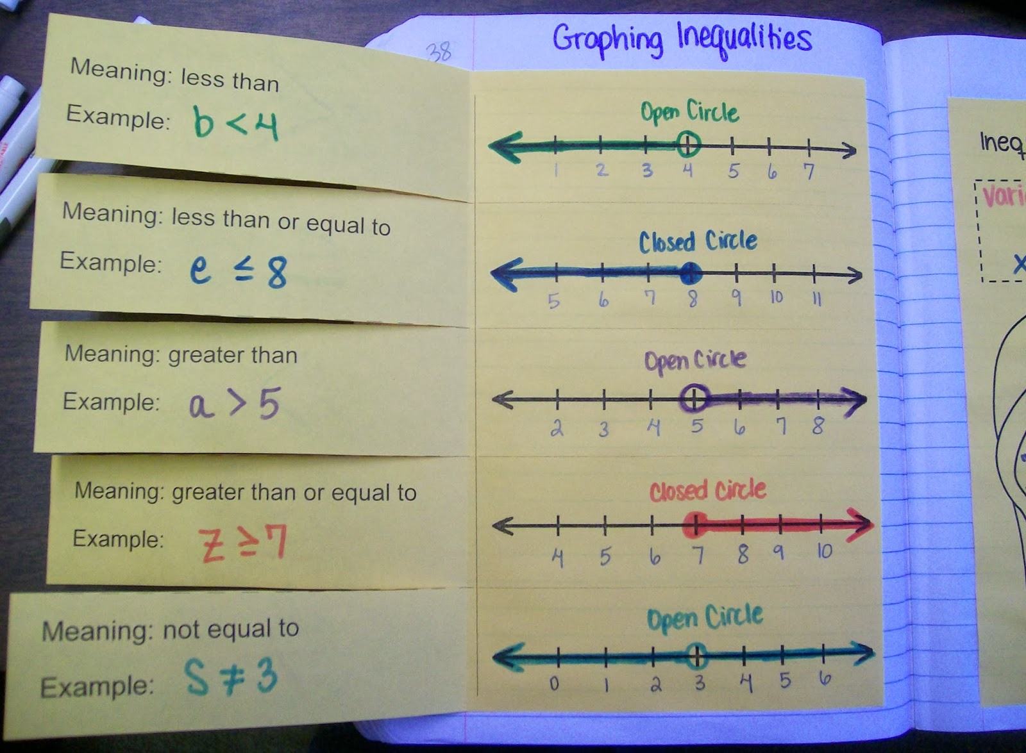

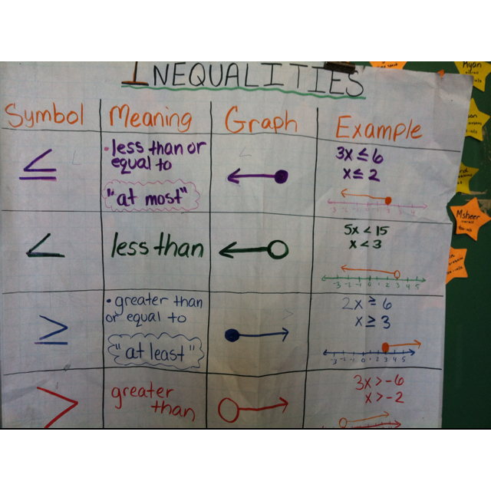
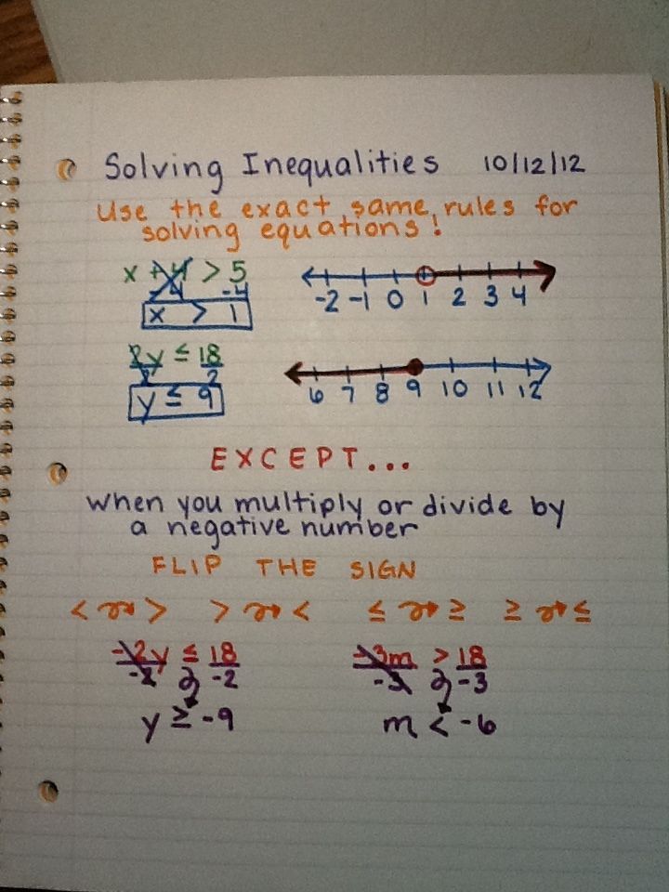

Assignment
LA #1 workbook page 70
LA #2 workbook page 74
LA #3 workbook page 78
LA #4 workbook page 82

Summarizing strategy

We will show that graphing an inequality is a range on the number line...a solution set. Hollow circle does not include (< or >). Solid circle includes (<= or >=). Solving Inequalities is very similar to solving equations. We must remember to flip the inequality when apply an inverse operation that is multiplying or dividing both sides of the inequality by a negative number.

