Learning Focused Lesson Plan Lynn W. Evans

Topic: Proportions

Scheduled time Math 7 2 days per lesson activity Total time 9 days
Accelerated math 1 day per lesson activity Total time 5 days

Standard:7.RP.2

Recognize and represent proportional relationships between quantities.

A. Decide whether two quantities are in a proportional relationship, e.g., by testing for equivalent ratios in a table or graphing on a coordinate plane and observing whether the graph is a straight line through the origin.

- Identify the constant of proportionality (unit rate) in tables, graphs, equations, diagrams, and verbal descriptions of proportional relationships.

- Represent proportional relationships by equations. For example, if total cost t is proportional to the number n of items purchased at a constant price p, the relationship between the total cost and the number of items can be expressed as t = pn.

- Explain what a point (x, y) on the graph of a proportional relationship means in terms of the situation, with special attention to the points (0, 0) and (1, r) where r is the unit rate.

Students will know:
- Two quantities are in a proportional relationship if the ratios are equivalent.
- Unit rate is also called the constant of proportionality.

Students will be able to:
- Test for proportional relationship by using equivalent ratios in a table or graphing on a coordinate plane and observing whether the graph is a straight line through the origin.
- Analyze tables, graphs, equations, diagrams, and verbal descriptions of proportional relationship to determine the constant of proportionality.
- Represent proportional relationships by equations.
- Explain what a point on the graph of a proportional relationship means in terms of the situation with special attention to the origin and (1, r), where r is the unit rate.

Learning essential question:

Activating strategy:
LA#1 Determining and checking proportions workbook pages 89 and 90
LA #2 Writing proportions workbook pages workbook pages 95-97
LA #3 solving proportions with science, recipes and criss-cross games workbook page 99-101
LA #4 comparing rates graphically workbook pages 103-105

Key vocabulary to preview and vocabulary strategy:

Proportional relationships, equivalent ratios, constant of proportionality, coordinate plane, coordinates, graphs, equations, tables

Lesson Instruction:
Learning activity #1: Proportions (section 5.2 in the text book)

Proportion An equation stating that two ratios are equivalent. 2/3 = 4/6

Proportional Two quantities that form a proportion are proportional.

If the two ratios can be written in an equivalent simplest form, they are proportional and equivalent fractions.

5/10 = 1/2
10/20 = 1/2......... 5/10 and 10/20 are equivalent ratios and are proportional.

Cross products property In the proportion a/b = c/d , the cross products of a times d = b times c .......ad = bc. If the cross products are not equal, then there is no proportion.

Using a table to determine if two items are proportional:

x | y
1/2 | 3
1 | 6
3/2 | 9
2 | 12

Compare each ratio of x to y in simplest form. (1/2)/3 = 1/6
1/6 = 1/6
(3/2)/9 = 1/6
(2/12 = 1/6
All ratios are equivalent, the table is proportional.

Using a graph to determine if a relationship is proportional.

The graph must be a straight line and go through the origin.

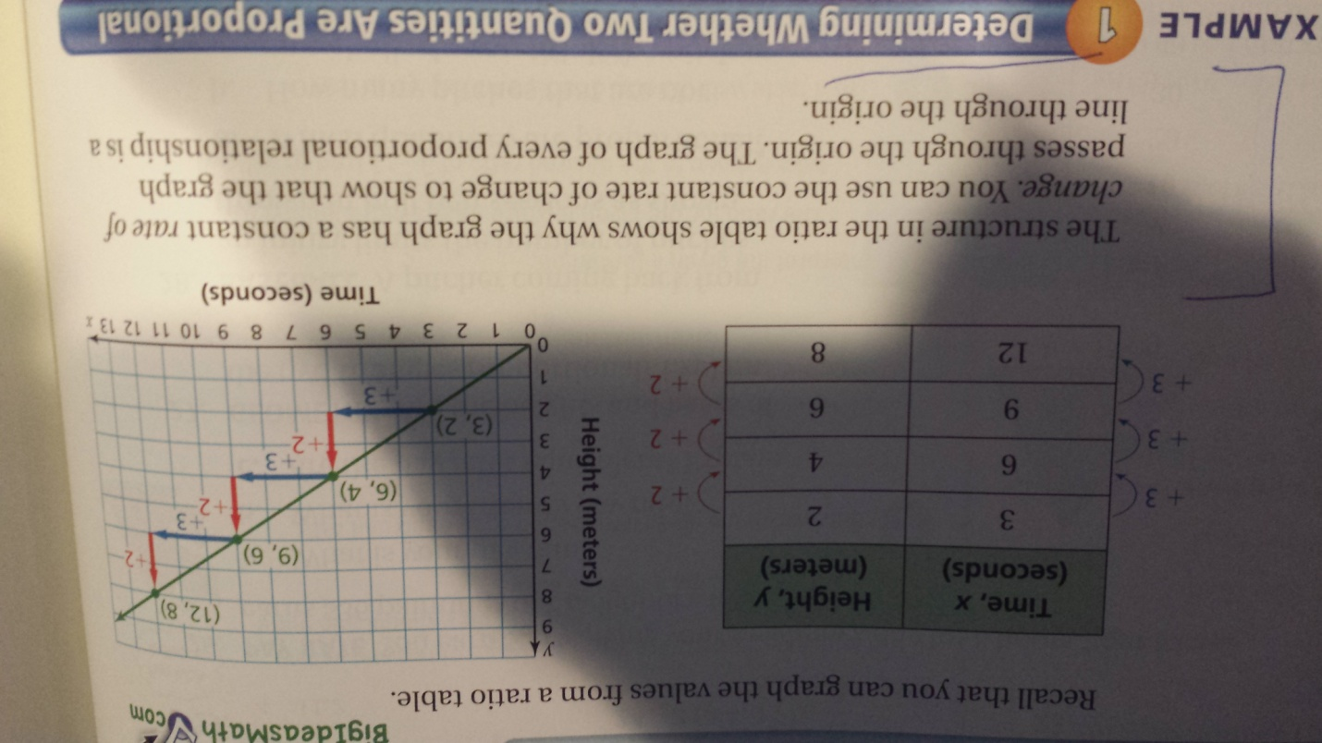

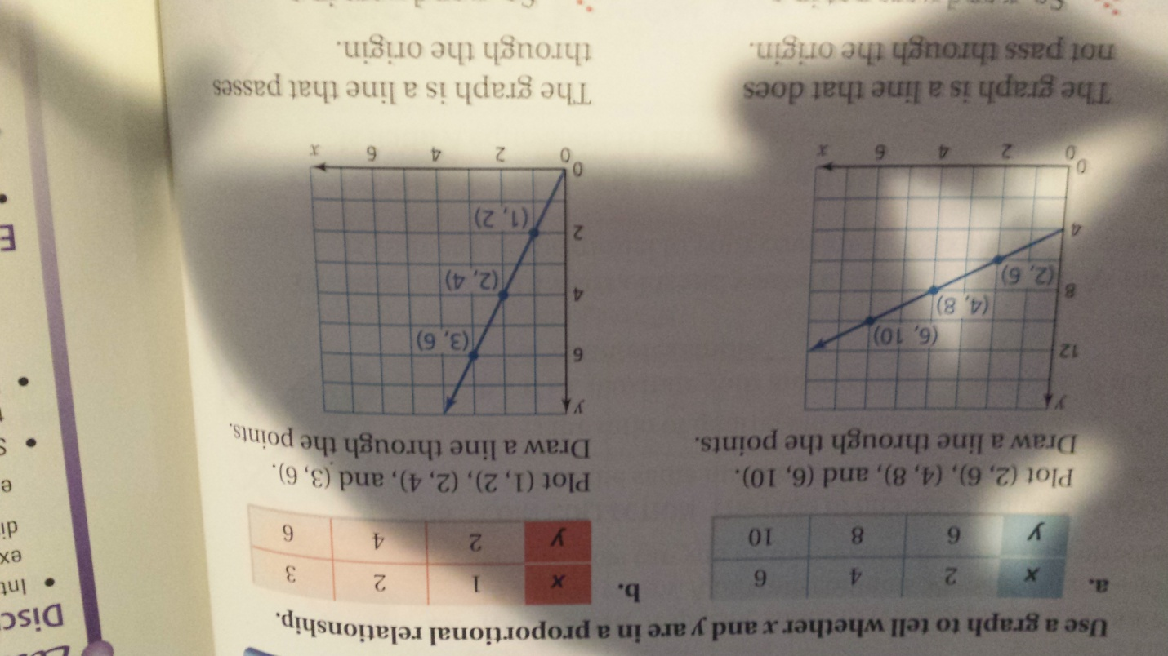

In a proportional relationship, the unit rate is the slope of the line. The unit rate must stay the same meaning the line must be straight. The unit rate can be determined by reading the graph at a unit of 1 for the denominator. In the above example b, the point (1,2) represents x =1 and y = 2. y to x or y/x = 2/1 the graph has a slope of 2 and the proportion has a unit rate of 2. We will deal more with slope later in this standard. It is important to note that the unit rate = slope and the unit rate can be read from a graph at the point (1,y) where y is the unit rate.

https://www.youtube.com/watch?v=USmit5zUGas

https://www.youtube.com/watch?v=USmit5zUGas

Assessment prompt for LA #1 (text book page 177)

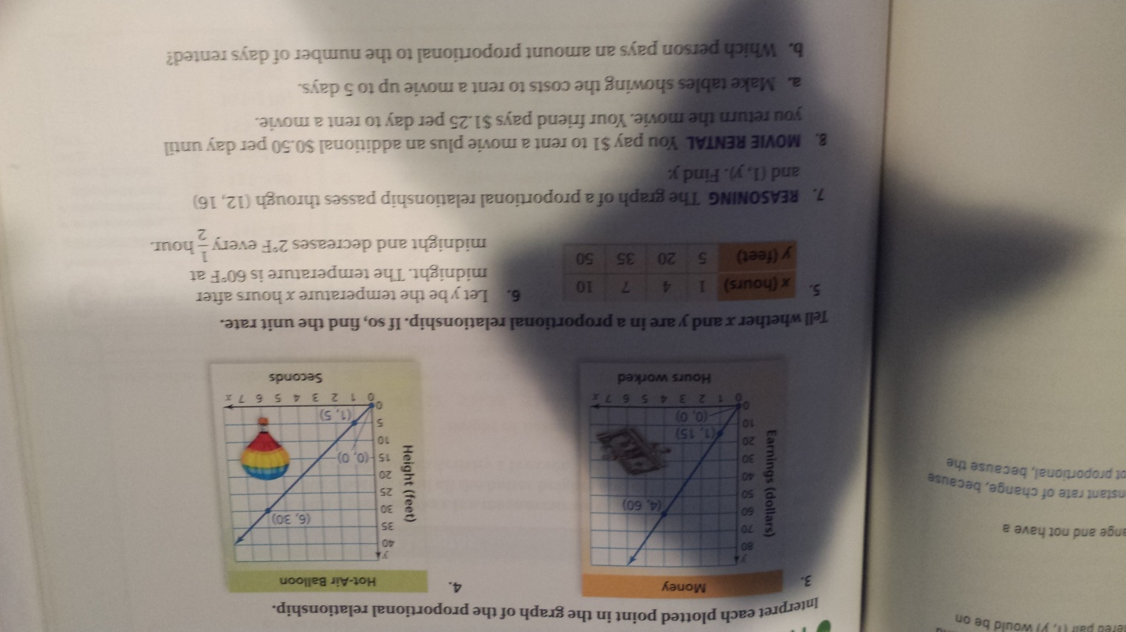

Learning activity #2 Writing proportions (section 5.3 in the text book)

One way to write a proportion is to use a table.
 | Last month | This month
purchase | 2 ring tones | 3 ring tones
Total cost | 6 dollars | X dollars
Use the columns or the rows to write a proportion.
Using columns 2 ring tones/6 dollars = 3 ring tones/x dollars
Using rows 2 ring tones/3 ring tones = 6 dollars/x dollars

https://www.youtube.com/watch?v=96ZEmUbnuU8

https://www.khanacademy.org/math/cc-seventh-grade-math/cc-7th-ratio-proportion/cc-7th-write-and-solve-proportions/v/writing-proportions

Assessment prompt for LA#2 (text book page 182)

Set up a proportion to find how many points are needed

a test worth 50 points and a test score of 40%

a test worth 80 points with a test score of 80%

Use the table to write a proportion

 | Game 1 | Game 2
points | 12 | 18
shots | 14 | w

 | May | June
winners | n | 34
entries | 85 | 170

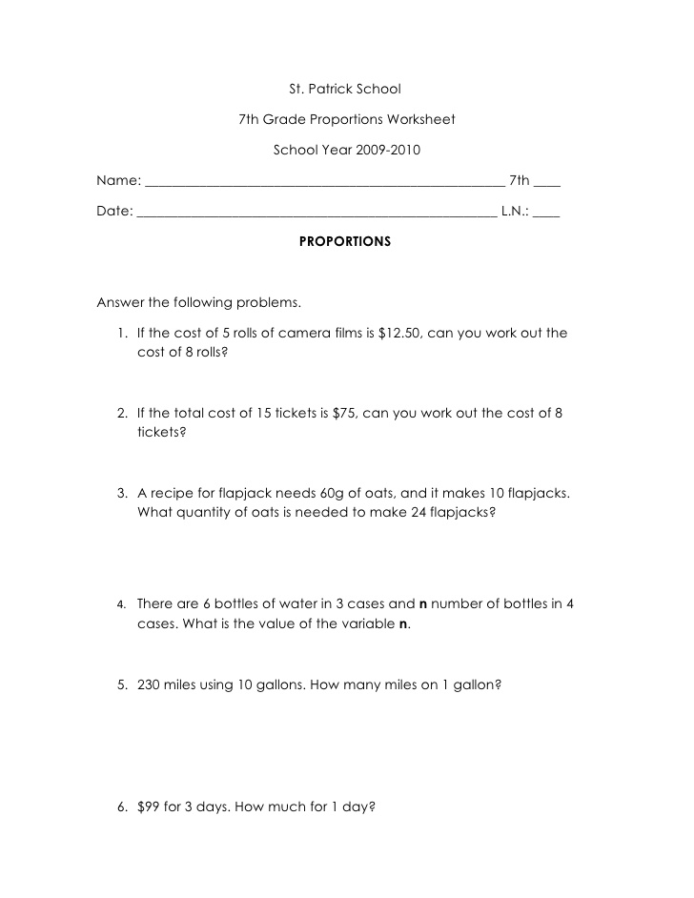

Learning activity #3 Solving proportions (section 5.3 and 5.4 in the text book)

We can use the cross products property, the multiplication property of equality and mental math (reasoning) to solve proportions...(key idea page 188 in the text)

Solving proportions using Multiplication: (examples page 188 in text)

5/7 = x/21 since x is divided by 21, we will multiply both sides by 21

21 (5/7) =21 (x/21)
15 = x
x = 15 I always like to finish with variable on the left.

Solving with the cross products property

x/8 = 7/10

x times 10 = 7 times 8
10x = 56
x = 5.6

Solving using mental math (page 181 in the text)

3/2 = x/8

notice that if we multiply 2 by 4 we get 8, so we multiply 3 by 4 to get 12

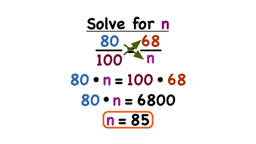
https://www.youtube.com/watch?v=bwIG4znuJZo

https://www.youtube.com/watch?v=kAW-JB1IVxA

https://www.youtube.com/watch?v=4JhPTVF7JDw

Assessment prompt for LA#3 (see text page 190)

Use multiplication to solve

9/5 = z/20

h/15 = 16/3

Use cross products to solve:

a/6 = 15/2

10/7 = 8/k

Do error analysis #22 on page 190 and Math deeper #36 on page 191 in the text.

Learning activity #4 Slope (section 5.5 in the text book)

Slope ..from the text page 194
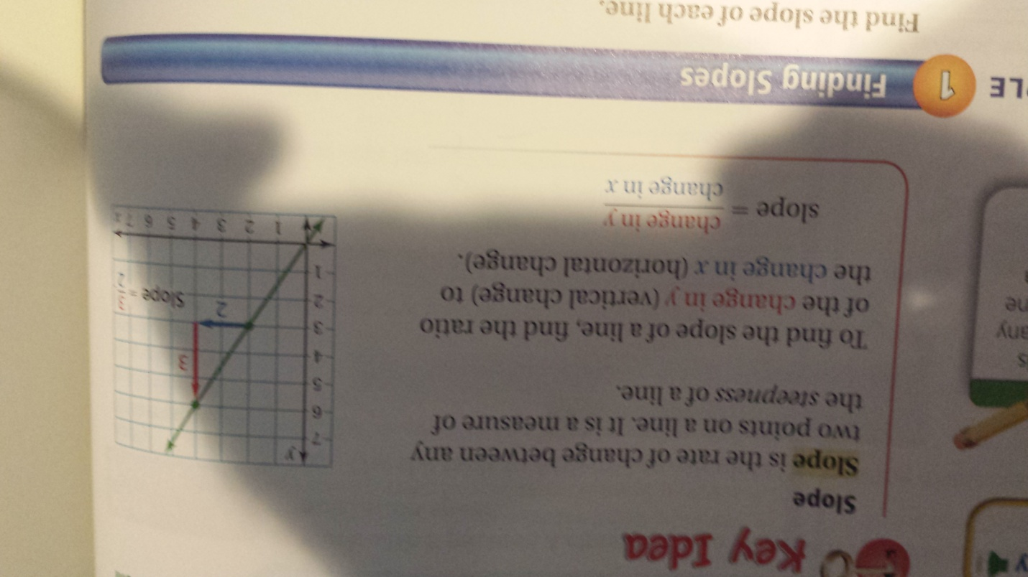

In the above graph, the slope = 3/2

Slope is called the rise/run or the change in y/ change in x

The slope of a proportional line is the unit rate and is also called the constant of proportionality. Remember, a line that represents a proportion must go through the origin.

A proportional line that goes through the point (4,5) would by definition also go through point (0,0). So, we have two points on the line (x1,y1)= (0,0) and (x2,y2) = (4,5)

Slope = change in y/ change in x
= (y2-y1)/(x2-x1)
=(5-0)/(4-0)
= 5/4 The slope is 5/4. The unit rate and constant of proportionality is 5/4. We will learn more about the constant of proportionality in the next standard (7.RP.3).

Slope from a table and graph (Text page 195)

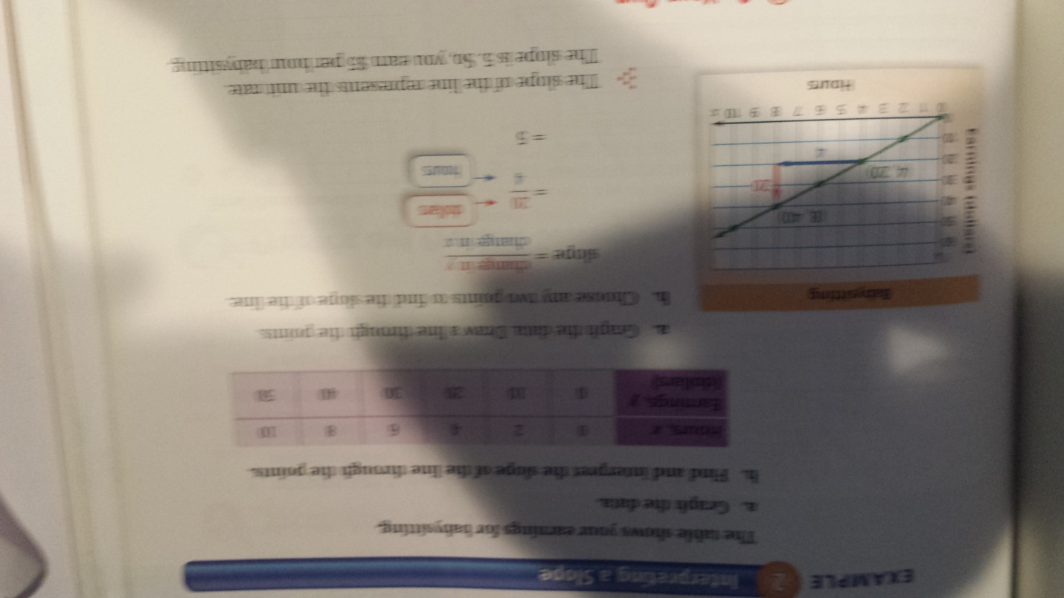

https://www.youtube.com/watch?v=R948Tsyq4vA

https://www.youtube.com/watch?v=z1-uYS6hsHQ

The steeper the slope the faster the rate of change.

Assessment prompt for LA#4 (see text page 196)

Problems #10-15 pages 196-197

Find the slope
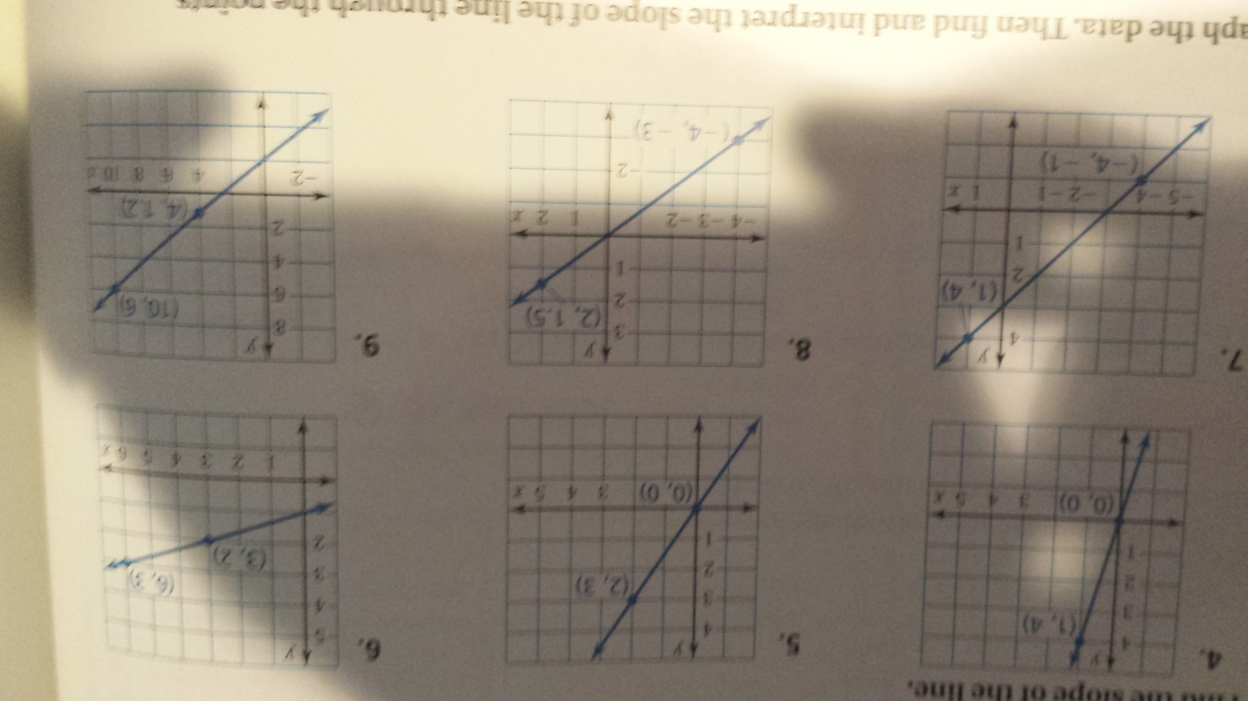

Graphic organizer
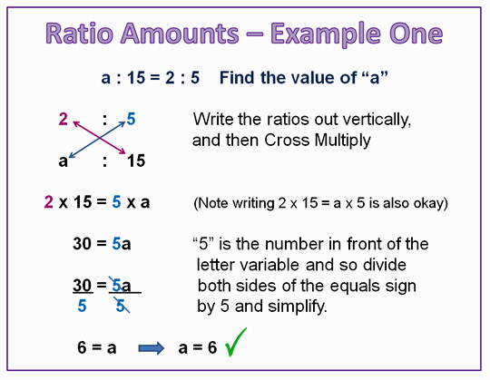
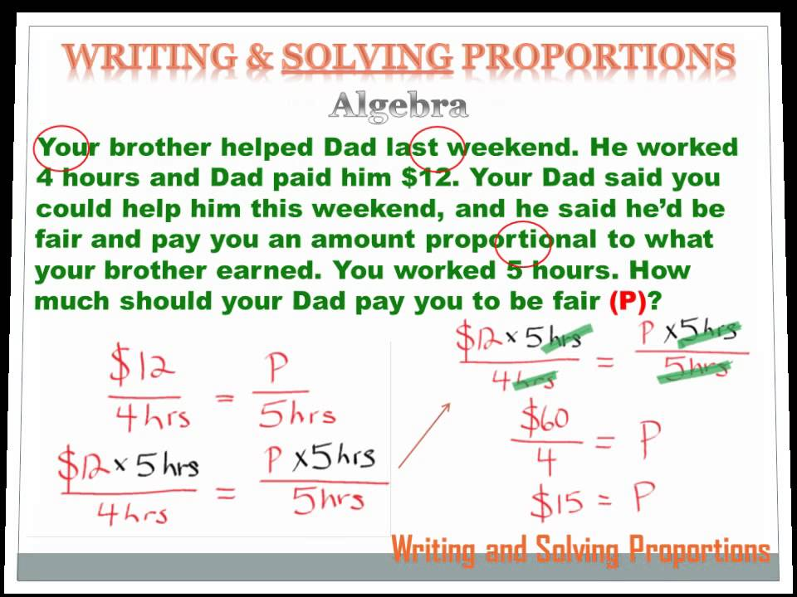

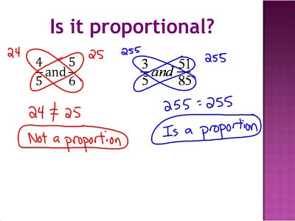

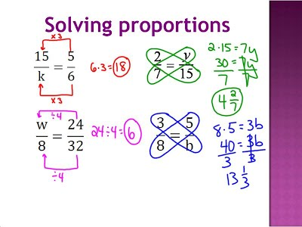

Notice the ratio of part to whole

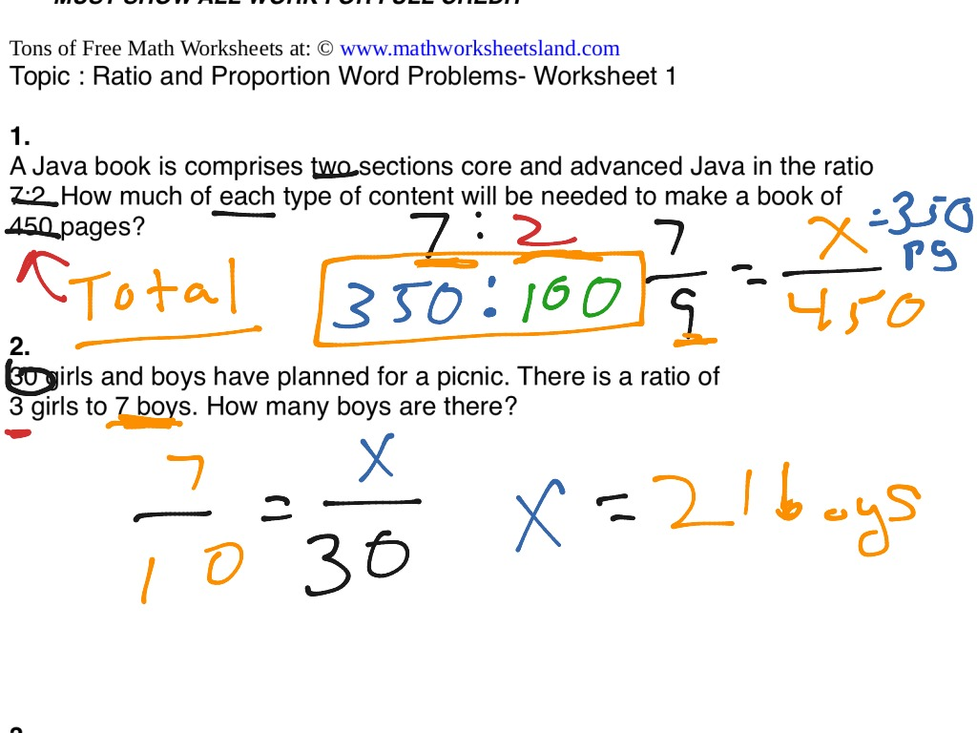

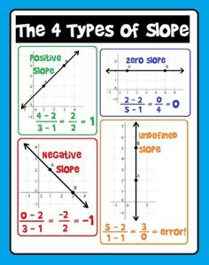

Assignment
LA #1 Workbook page 92-94
LA #2 Workbook page 98
LA #3 Workbook page 102
LA #4 Workbook page 106

Summarizing strategy

We learned that two quantities are proportional relationship by testing for equivalent ratios. We also learned to determine a proportion using tables and graphs. We learned that proportions can be solved using cross products and the multiplication property of equality. Graphs of proportions must go through the origin. Slope is defined as change in y / change in x......referred to as rise/run. The slope of a line representing a proportion is the unit rate of the proportions. The slope of a line of a proportion is also called the constant of proportionality, which is the focus of our next standard.

